Natural Stone – Things to be aware of
Natural stone can have various marks such as brown/black areas (Fossil / Crystallisation) or lines across the paving (Veins) these are Permanent Natural Characteristics of the stone and should be considered as part of the beauty of natural stone rather than a defect.
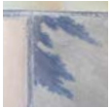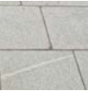
Fossil Crystallisation Veins

When laying Natural Stone there are Natural occurrences that can be visible in the majority of cases these will eventually fade over time.
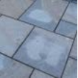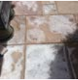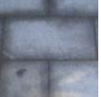
Moisture Transparency Efflorescence Picture Framing around the edges of the slab Dark and light patches White, Cloudy bloom marks Darker colouration
Result of wet mortar absorbed through stone Salts from mortar drawn through paver Will remain until paver
fully dried out

Specialist products are available to remove these marks. Ensure you read the instructions in full and if in doubt check with the cleaning product manufacturers in addition test on a small discreet area.
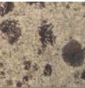
Lichen

